HR Clocker

# File Watcher Service Installation Guide

Open and run the FileWatcher.exe.

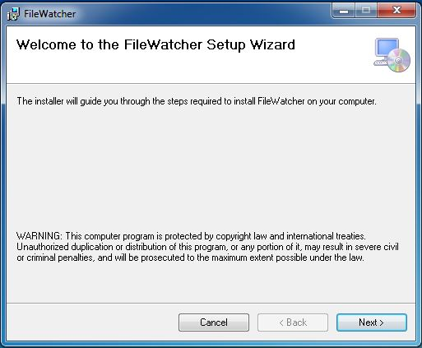

Install the service in the C: Drive (NOT in Program Files(x86) or Program Files).

Note: Installing the service in Program Files folder won’t let you to edit the watch location path.

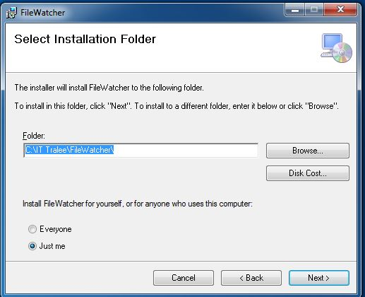

The default location path is “C:\Clockrite\Database”, where FileWatcher Service checks for the new files from the Clockrite Hardware.

In case, if the service doesn’t find this location path, the service is automatically stopped.

You can change this default location to the new one by following steps below:

* Open the FileWatcher Folder from the C: Drive

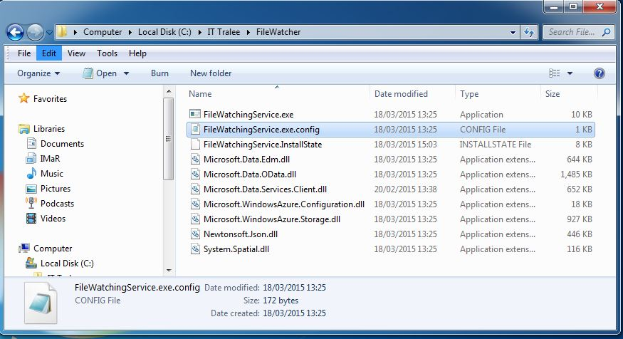

* Open the FileWatchingService.exe.config file, using a Text Editor

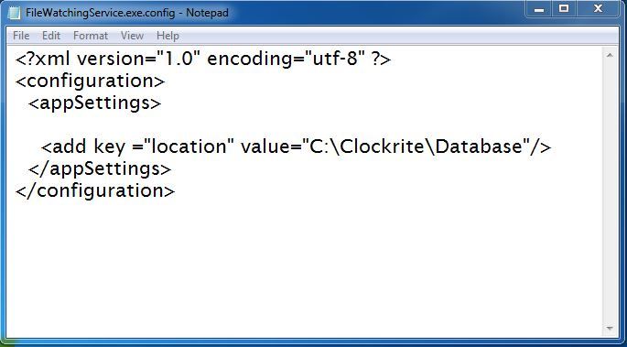

* You can change the value “C:\Clockrite\Database” to your new desired location path and save it.

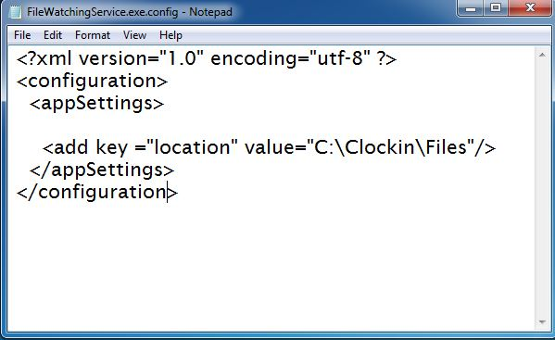

* Make sure the service “FileWatcher” is running back again.

